Step by step guide for AWS Account Creation :

1. Navigate to Amazon Web Services (AWS) home page.

* Link : <https://aws.amazon.com/>

1. For first time login – Choose “ Create an AWS Account”

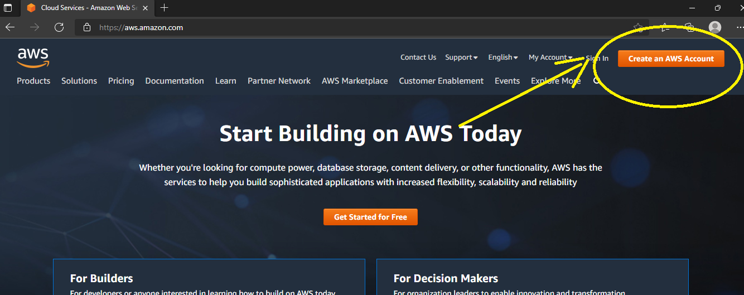

1. Fill in the required details in Sign up page :

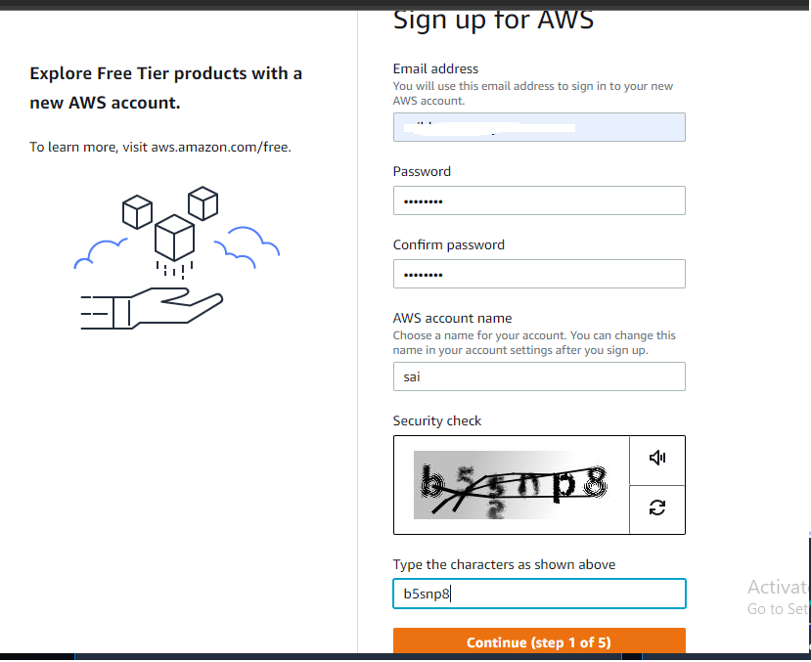

1. Fill the personal information :

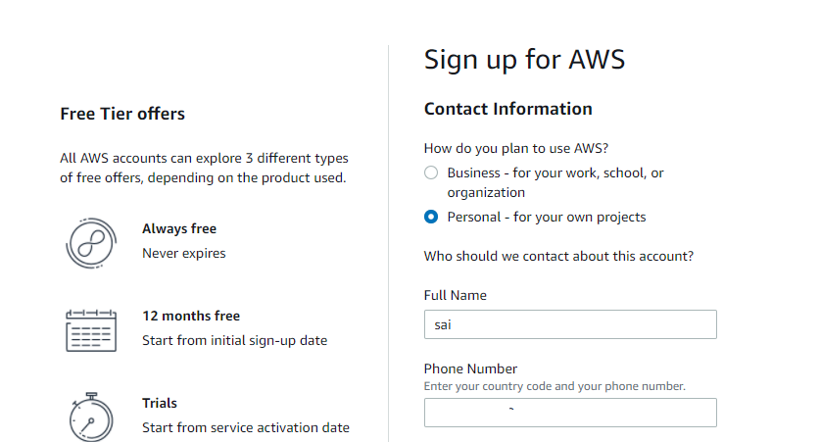

1. Enable I have read and Agree Check box and proceed to next step

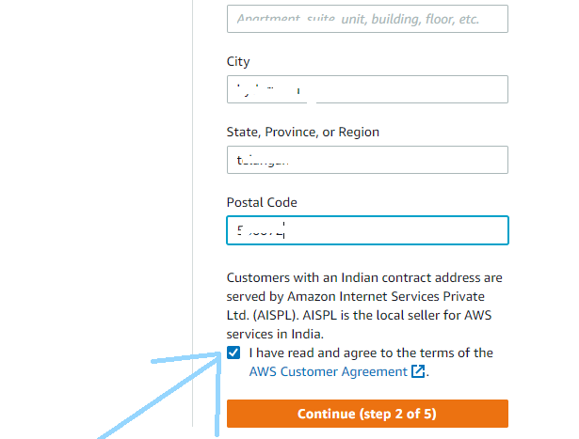

1. On the Billing information page, enter the information about your payment method.

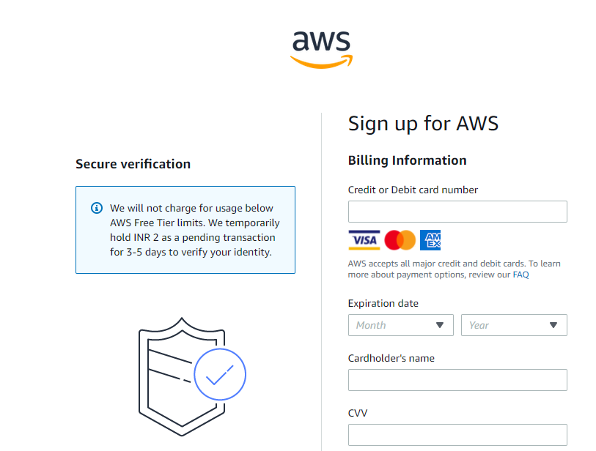

1. Verify your phone number

* On the Confirm your identity page, select a contact method to receive a verification code.
* Select your phone number country or region code from the list.
* Enter a mobile phone number where you can be reached in the next few minutes.
* If presented with a CAPTCHA, enter the displayed code, and then submit.
* In a few moments, an automated system contacts you.
* Enter the PIN you receive, and then choose Continue.

1. Choose an AWS Support plan.
2. Choose Complete sign up.

PS :

* If you already have an aws account, follow the below steps , else ignore Step 3
* If you signed in to AWS recently, choose Sign in to the Console.

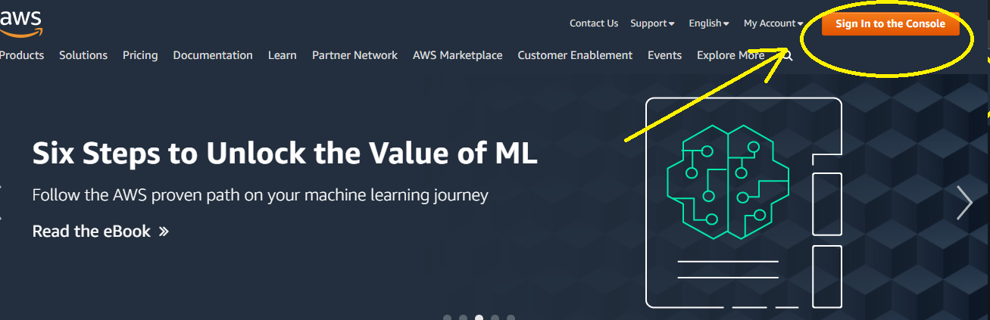

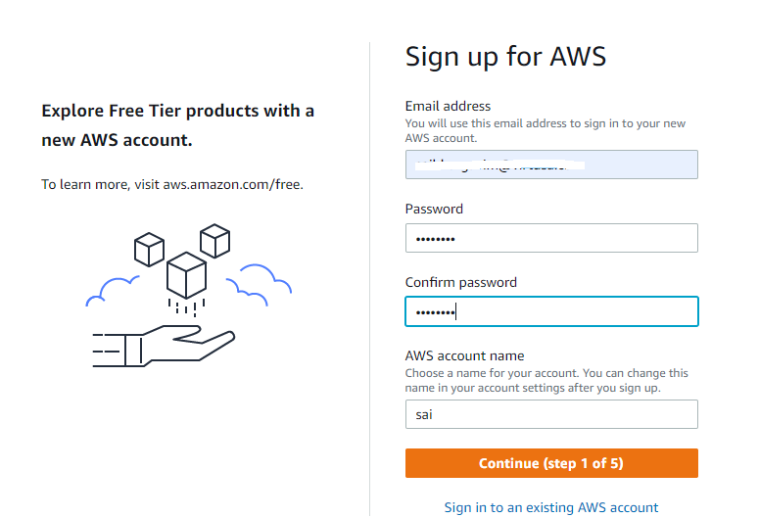

For Example :

* Email Address : [xxx@gmail.com](mailto:xxx@gmail.com) – personal email id
* Provide a strong password and save it for future logins
* AWS account name : Your name which would be displayed for your AWS account in future.
* 
* Enter your email address, password, AWS account name, and then choose Continue. Be sure that you enter your account information correctly, especially your email address. If you enter your email address incorrectly, you can't access your account.)

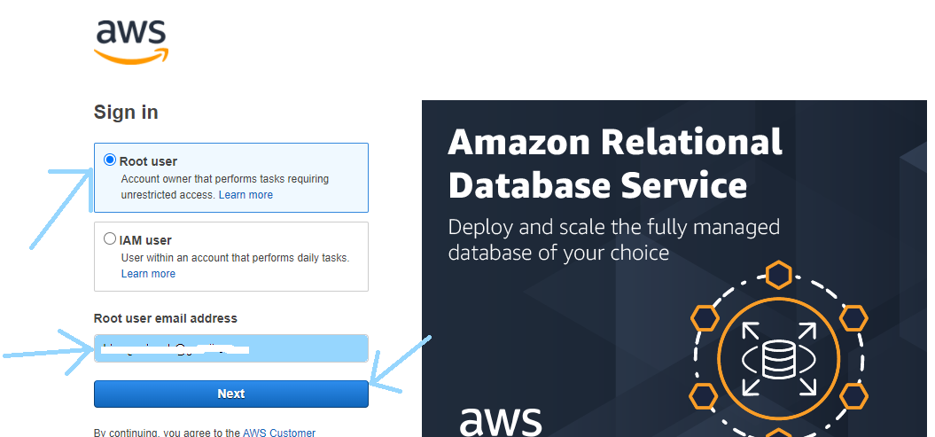

* If Create a new AWS account isn't visible, first choose Sign in to a different account, and then choose Create a new AWS account.

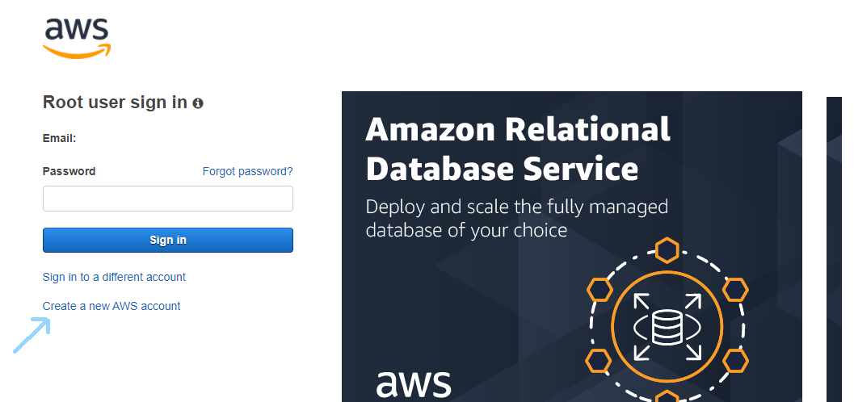

Creating Access Key and Secret Key in AWS account

* Navigate to the below link and sign in to AWS console.

Link : <https://aws.amazon.com/console/>

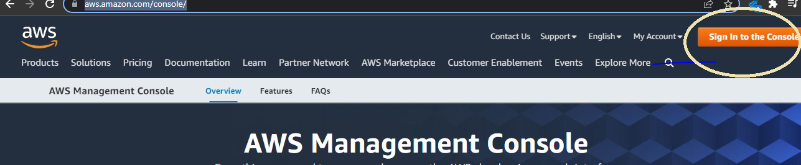

* Login as root user and specify the required credentials.

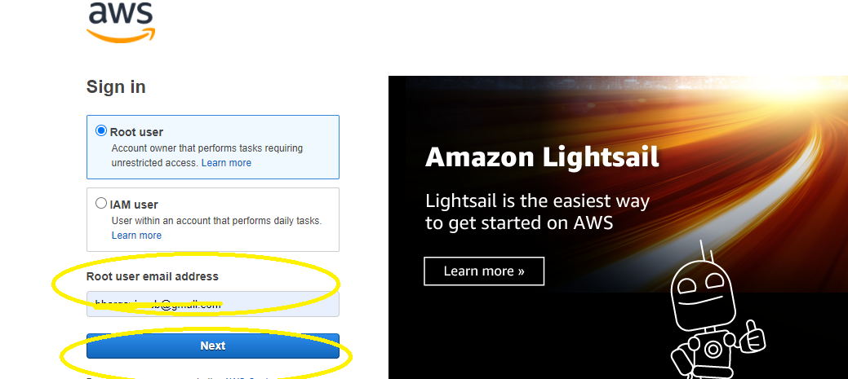

* After logging into the account, click on the drop down box available at the top right of your profile and navigate to “Security Credentials” option as shown below.

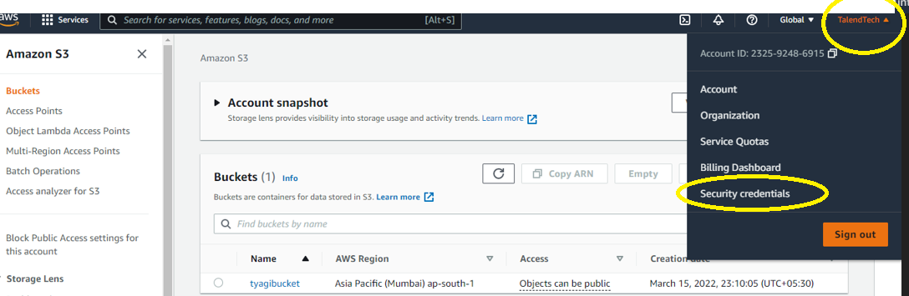

* After navigating to next page, Click on “Access Keys” drop down box available in the web page.

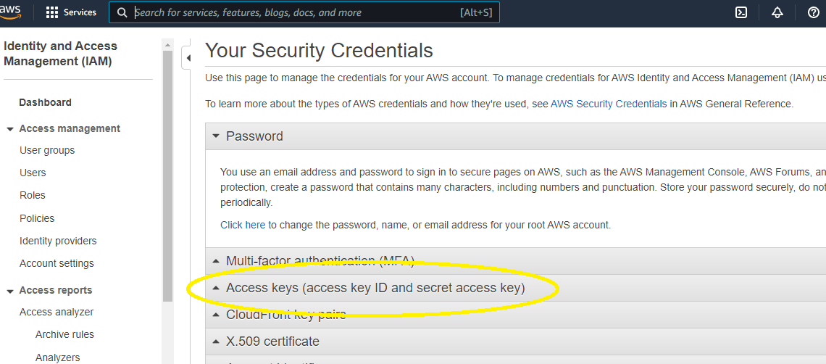

* Click on “Create New Access Key” as displayed in below screenshot

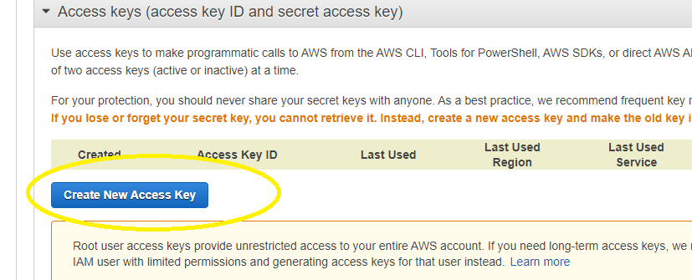

* A key file will be created and will be available for download option to download the key file which consists of credentials information.

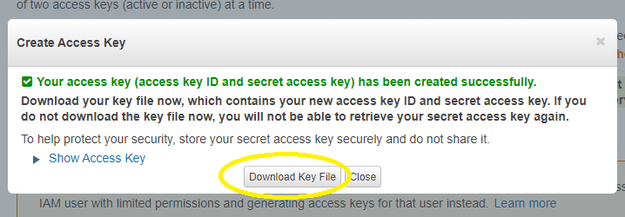

* Download the key file and credentials will be valid for few days to use in talend job and new access key has to be generated by deleting the previous access key if the credentials are expired.
* Deletion of access key can be done by de activating it and deleting it as shown in below screenshot.

